**Blotto Swarm**

“Do I have to say something?”

― Eric Oh

There are 30 points located around a circle, and 10 castles are located on 10 of these points such that there are 2 points between adjacent castles. You and your opponent each have 60 soldiers which may move around the circle, and your goal is to have your soldiers occupy a majority at castles.

The game lasts for 100 days. Soldiers start at a random point on the circle. On each turn, each soldier receives information about the number of ally and enemy soldiers in the 7 points closest to the soldier. (See figure on the next page) The soldier decides whether to move a point clockwise around the circle, counter-clockwise, or stay at the current point. All soldiers move simultaneously. At the end of the day, for each castle in which you have a majority of the number of soldiers occupying that point, you gain one point.

You are to implement one function *soldier*, which drives a single soldier.

* *soldier* takes as input two lists and one integer: *ally* and *enemy,* both of which are a list of 7 integers, and *offset,* which is an integer between -1 and 1.

Suppose that the soldier is located at point x (where x is taken modulo 30).

Then, *ally*[i] contains the number of ally soldiers at point x + i - 3. Notably, *ally*[3] contains the number of ally soldiers (including oneself) at point x.

Likewise, *enemy*[i] contains the number of enemy soldiers at point x + i - 3.

*offset* denotes the unique integer i between -1 and 1 such that a castle is located at x + i. It is worth noting that *soldier* does not know their absolute position x on the circle.

* *soldier* should output a single integer j between -1 and 1, indicating that the soldier wants to move to point x + j. In the event of an invalid output, the output will be treated as a 0.

An instance of *soldier* may store up to 16MB of memory, and use up to 0.5 seconds of time over 100 days. *soldier* will be called once every day for 100 days in total. At the end of each day, at each castle the player with a majority number of soldiers gains one point. After 100 days have elapsed, the number of points is tallied, and the player with more points wins.

Clarification: Soldiers have separate instances and they move independently.

They do not share memory.

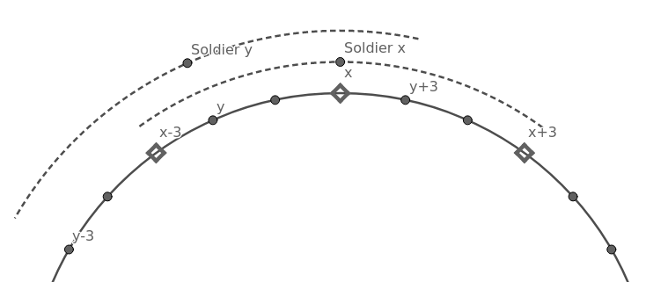

In this figure, diamond points are points on the circle with a castle. For soldiers x and y, the arc denotes the range of points they see.